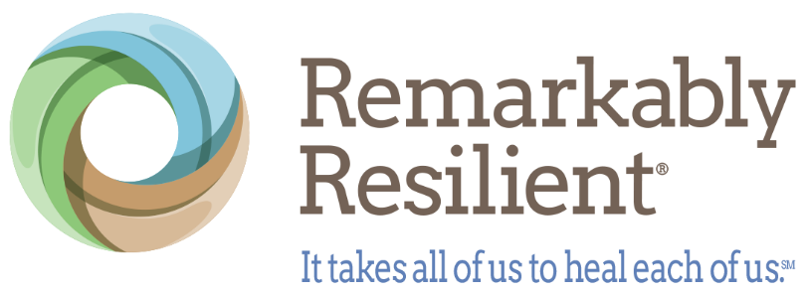

NEWS RELEASE

Media Contact:
Elaina Boudreau
BELA Communications
913.660.0548; eboudreau@belapr.com

Remarkably Resilient Launches Nationwide Continuing Education to Help Nurses Strengthen Their Own Well-Being

New online course provides 1.5 accredited nursing contact hours as The Pitt and growing research spotlight the urgent need for healthcare worker well-being

KANSAS CITY, Mo. (July 28, 2026) – From the emotional realities portrayed in HBO Max's The Pitt to a growing body of research on burnout and compassion fatigue, the importance of healthcare professional well-being has never been more visible.

Growing evidence links chronic workplace stress among nurses to burnout, turnover and workforce shortages, increasing demand for practical tools that help healthcare professionals build resilience.

To help address that need, Remarkably Resilient, Inc. has launched a new online continuing education course that equips nurses with practical resilience-building skills while providing 1.5 accredited nursing contact hours. The self-paced course is available nationwide through the organization's online Learning Management System and is approved by the VTL Center for Professional Development, an accredited approver by the American Nurses Credentialing Center's Commission on Accreditation.

Unlike many continuing education programs that focus primarily on improving patient care, Remarkably Resilient Together (RRT): Regulation and Self-Care for Nursing Professionals focuses on caring for the caregiver.

“Healthcare professionals spend their careers helping others navigate trauma, crisis and uncertainty,” said Kathleen Harnish McKune, CEO and Co-Founder of Remarkably Resilient. “But too often, nurses receive little education on recognizing the effects of chronic stress within themselves. We created this course to help nurses strengthen their own resilience with practical skills they can use during a shift, after work and throughout their careers. When caregivers are equipped to care for themselves, everyone benefits – including the patients and families who rely on them.”

The fully online, self-paced course includes four instructional video modules totaling approximately 90 minutes, downloadable resource guides and practical techniques grounded in the neuroscience of trauma, emotional regulation and self-care. Participants have 30 days after enrollment to complete the course at their own pace.

Through four engaging video modules, participants hear directly from RRT co-founders Kathleen Harnish McKune and Karen Dickson alongside a panel of professionals, creating a practical blend of neuroscience, lived experience and professional expertise. The course translates the science of trauma and healing into evidence-informed emotional regulation and self-care strategies that nurses can apply immediately to strengthen their own well-being while enhancing their ability to care for others.

"As the Nurse Planner for the Remarkably Resilient Together nursing accreditation process, I reviewed peer-reviewed nursing literature that reinforced the importance of emotional regulation and self-care in healthcare systems,” said Graceann Sandri, APRN. “With the relentless demands, burnout, secondary trauma and compassion fatigue that are often present in our profession, learning the why and how of regulation and self-care are important human skills that help create a calmer, more engaging environment in which employees and patients alike can thrive.”

Registered nurse Angie Berrett, RN, host of the Healing Doesn't Have to Be Heavy podcast, said the training addresses an important gap in continuing education.

“As a registered nurse of 23 years, this training stood out to me because it puts the focus on the nurse, not on how to be a better caregiver for patients. If you're a nurse who has ever felt like your own well-being comes last, this training sees you.”

Hospice nurse Tanya S. Wilburn, RN, said the training acknowledges the emotional burden many nurses quietly carry throughout their careers.

“As a hospice nurse, I witness grief and loss every day. While it is an honor to care for patients and families at the end of life, the emotional impact of this work can accumulate over time and lead to compassion fatigue. I felt seen not only as a nurse, but as a human being. The tools provided will help me continue doing this meaningful work without losing myself in the process.”

The course is available to nurses nationwide for $50 per participant, with discounted pricing of $45 per participant available for organizations purchasing 100 or more seats. Healthcare systems and organizations may also license the training for their nursing teams.

As healthcare organizations continue seeking evidence-informed approaches to improve employee well-being, retention and patient care, the course offers a practical resource that supports both caregivers and the people they serve.

In addition to the nursing-specific course, Remarkably Resilient also offers online Regulation and Self-Care workshops for all audiences, guided reflective journals and additional resilience resources. English-language workshops are available now, with Spanish-language versions planned for September 2026.

To learn more or enroll in the course, visit the RRT: Regulation and Self-Care for Nursing Professionals course page. To explore organization-wide licensing opportunities, please call 913-706-8797.

About Remarkably Resilient, Inc.
Founded in 2024, Remarkably Resilient, Inc. is a 501(c)(3) nonprofit dedicated to empowering people to live happier, healthier lives by understanding the impacts of trauma and stress and practicing resilience-building skills. Co-founded by sisters Kathleen Harnish McKune and Karen Dickson, the organization combines the neuroscience of trauma with the founders' lived experiences to create practical, evidence-informed resilience education for individuals, healthcare professionals and organizations. Their work was inspired by their 2019 book, Remarkably Resilient: Community Matters. Through its signature program, Remarkably Resilient Together, the organization provides practical, evidence-informed tools to regulate emotions, reduce stress and build connections. To learn more, access tools or support the mission, visit www.remarkably-resilient.com

###

